Prototype for Web Tech Project

# Project Title: Event Planner Management System

## Section: I

## Group No: 09

Project Contributors:

|  |  |
| --- | --- |
| Student Id | Name |
| 18-37736-1 | BITHI, FARJANA ISLAM |
| 17-33907-1 | KHAN, ABRAR AHMED |
| 18-36556-1 | ALAM, MD. SHAKIBUL |
| 18-37740-1 | AHMED, IMTEAJ |

User Interface Pages:

Landing Page:

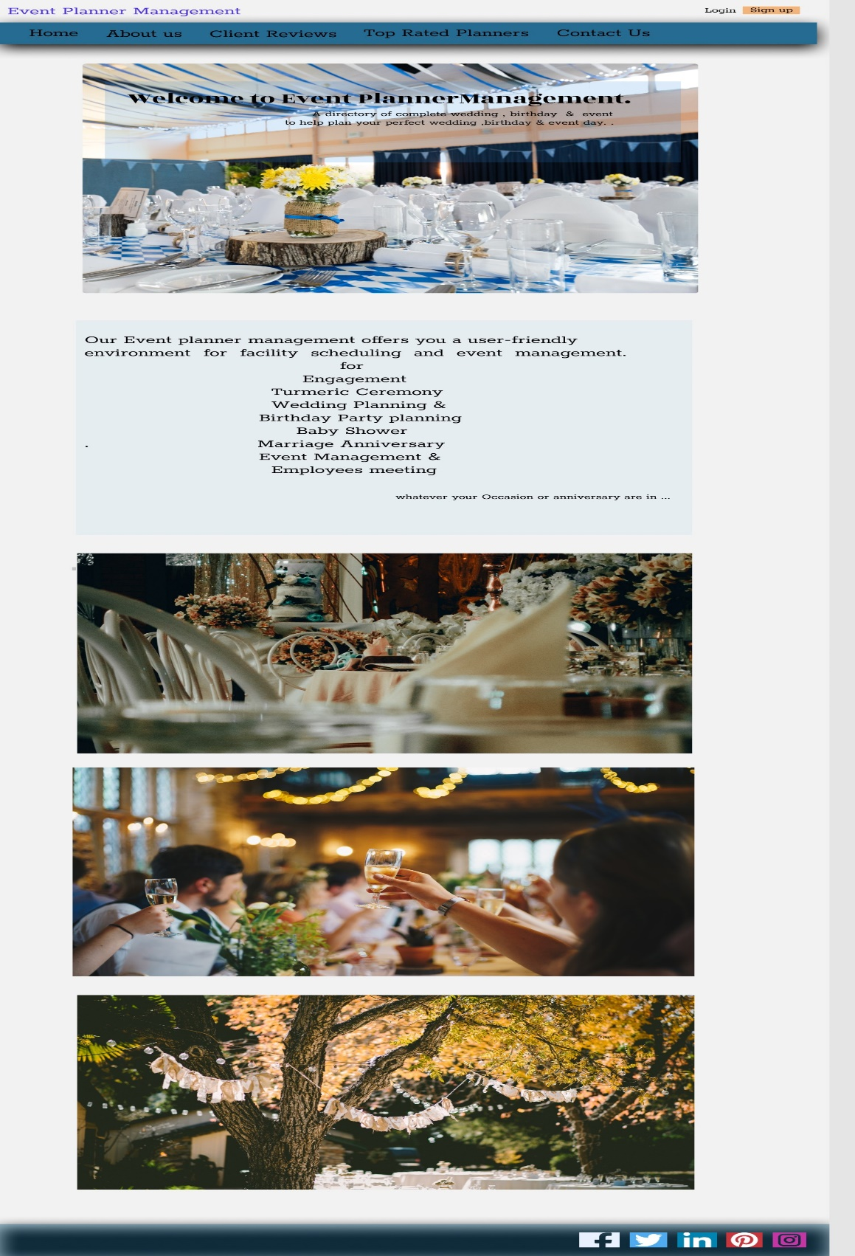

Login Page:

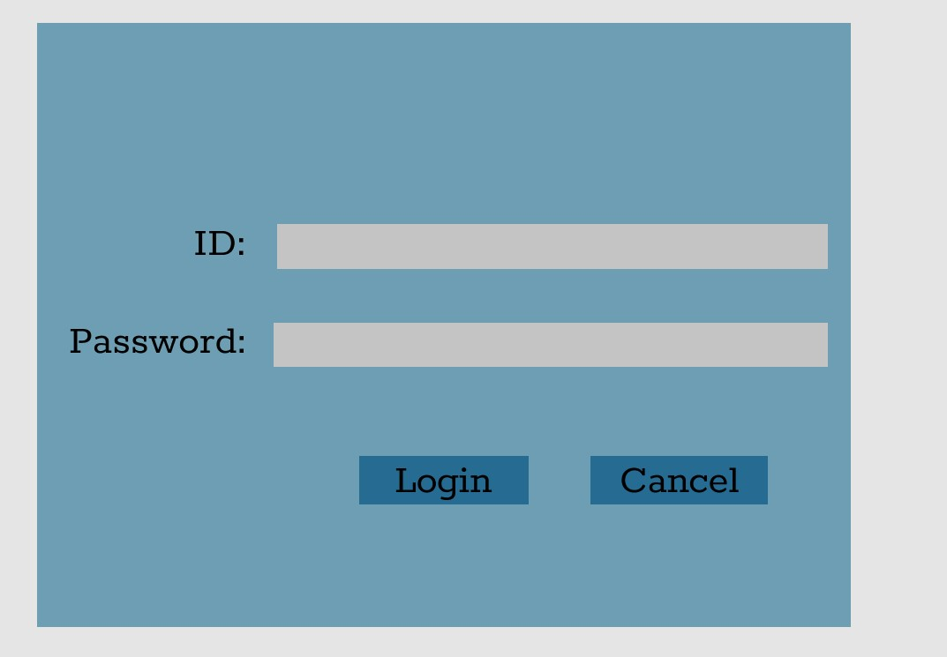

Register Page:

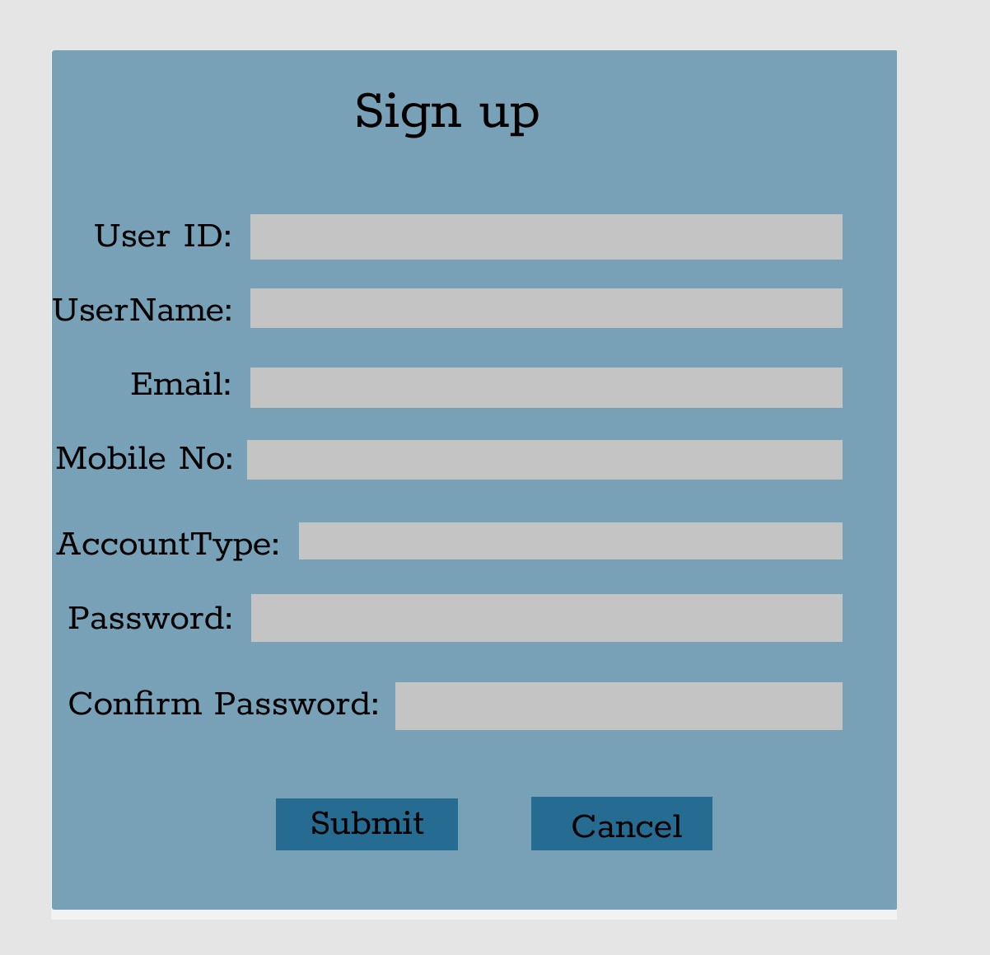

User After Login to Homepage:

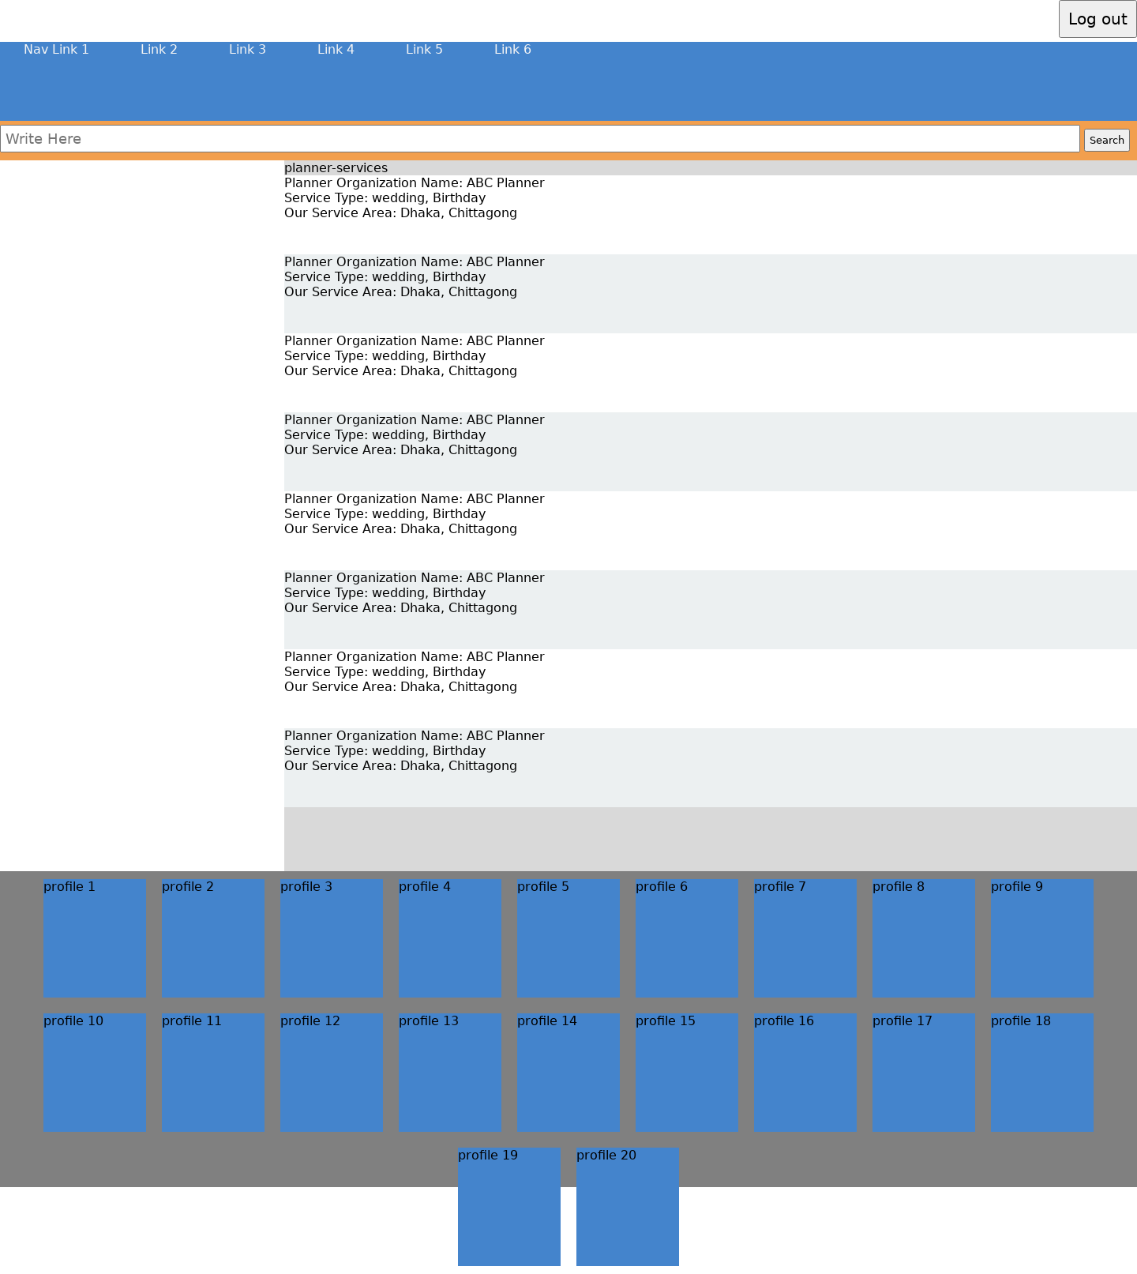

Profile:

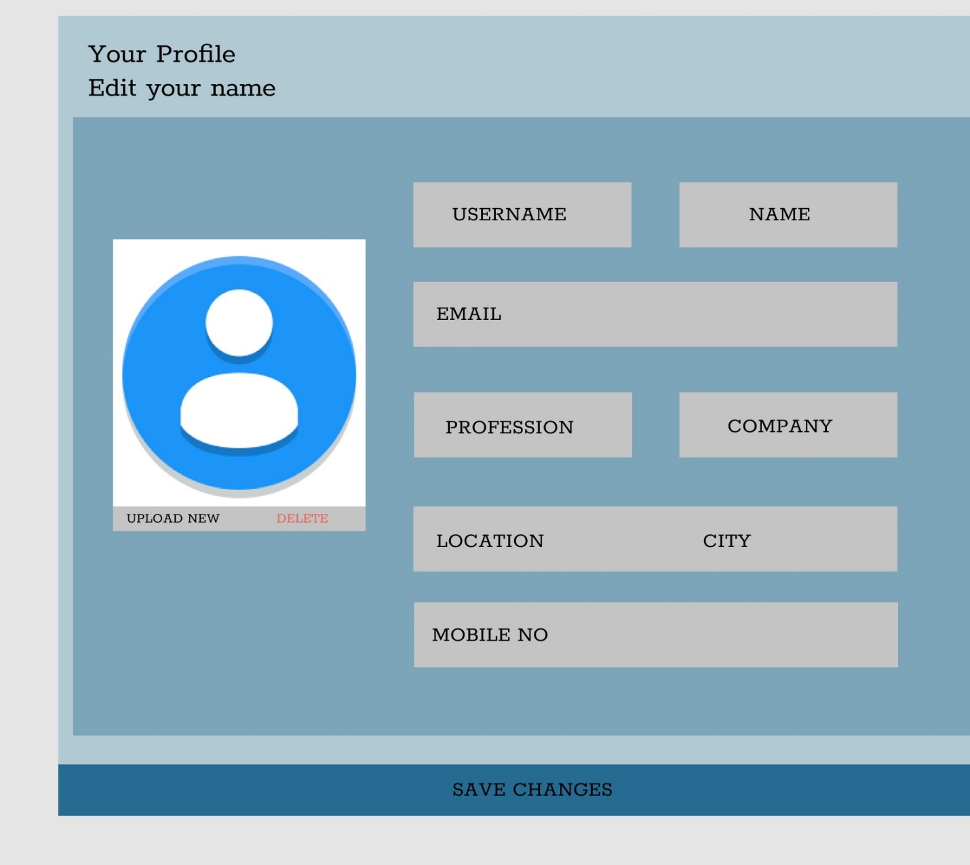

Planners Services and Price Tag:

